1. Watch terraform-05 video.  
   Done.
2. Execute the script shown in video.  
   Creating s3 bucket using terraform:

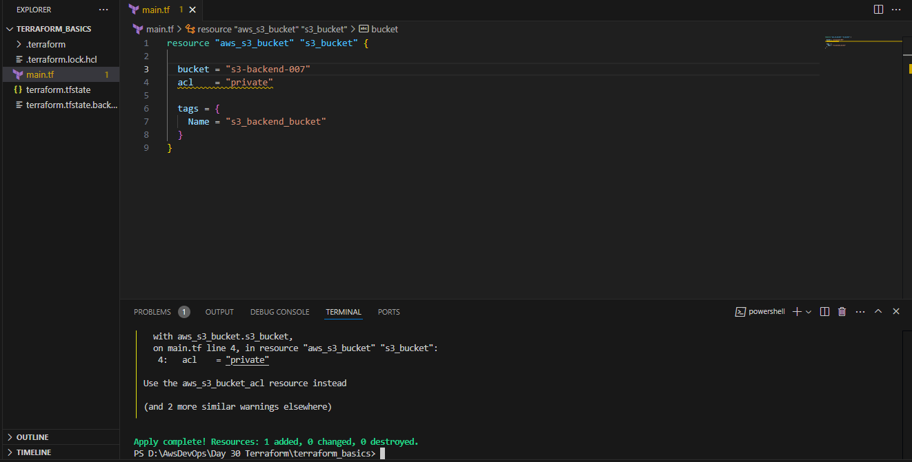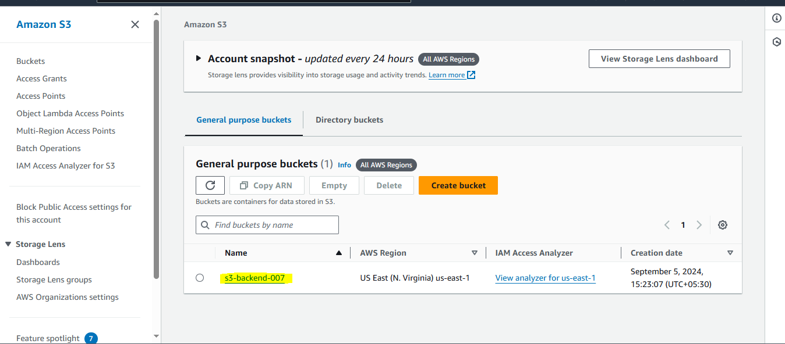  
Let’s attach dynamo db and lock the bucket with it:  
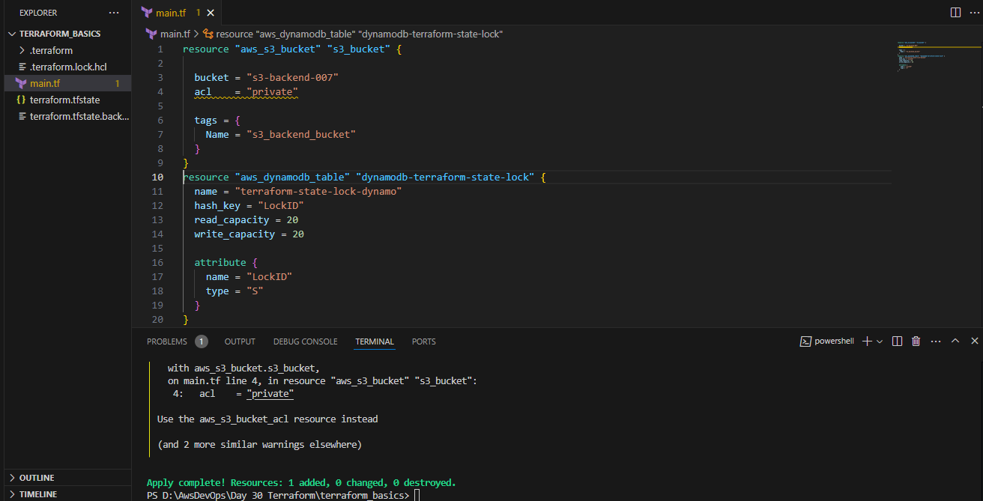  
Done:

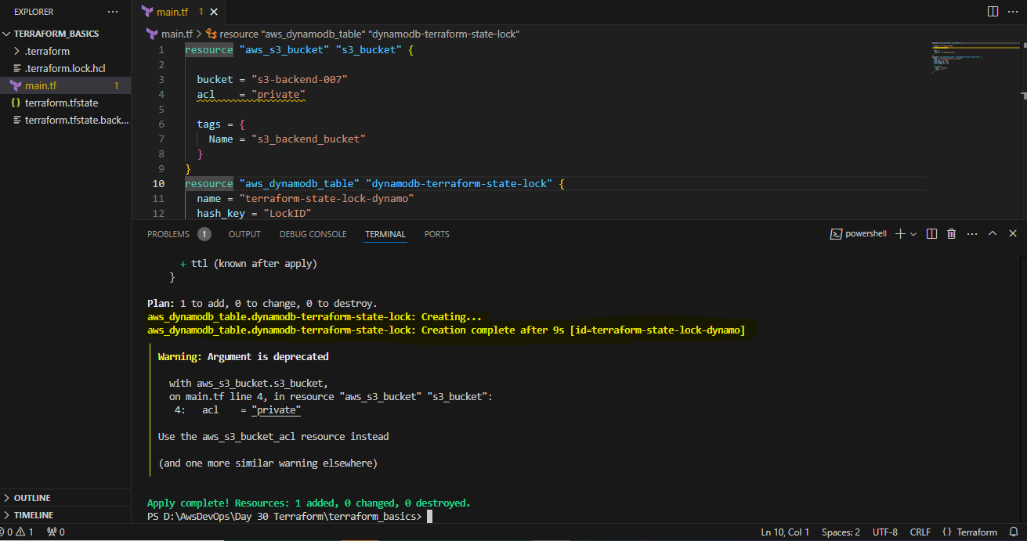

Created Dynamo DB successfully:  
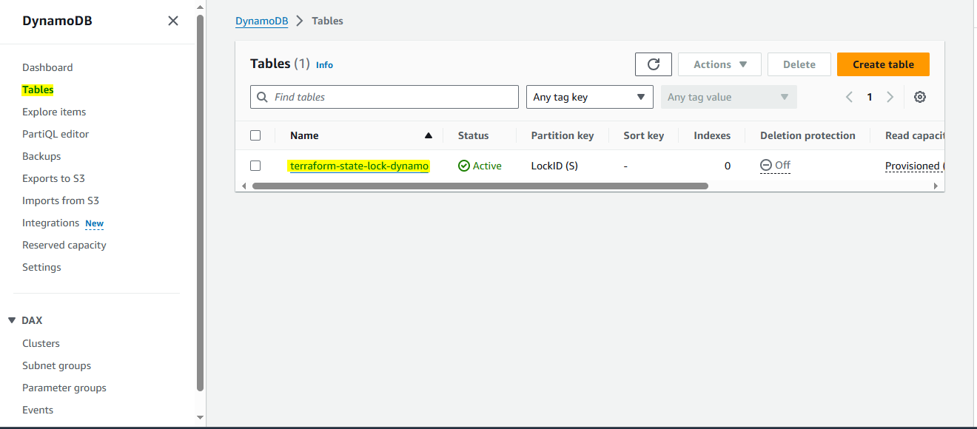Configuring the backend:  
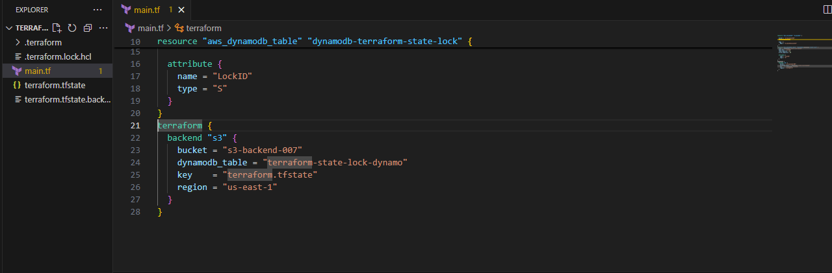  
by running the above script the **terraform.tfstate** file is emptied and it has been pushed to the S3:  
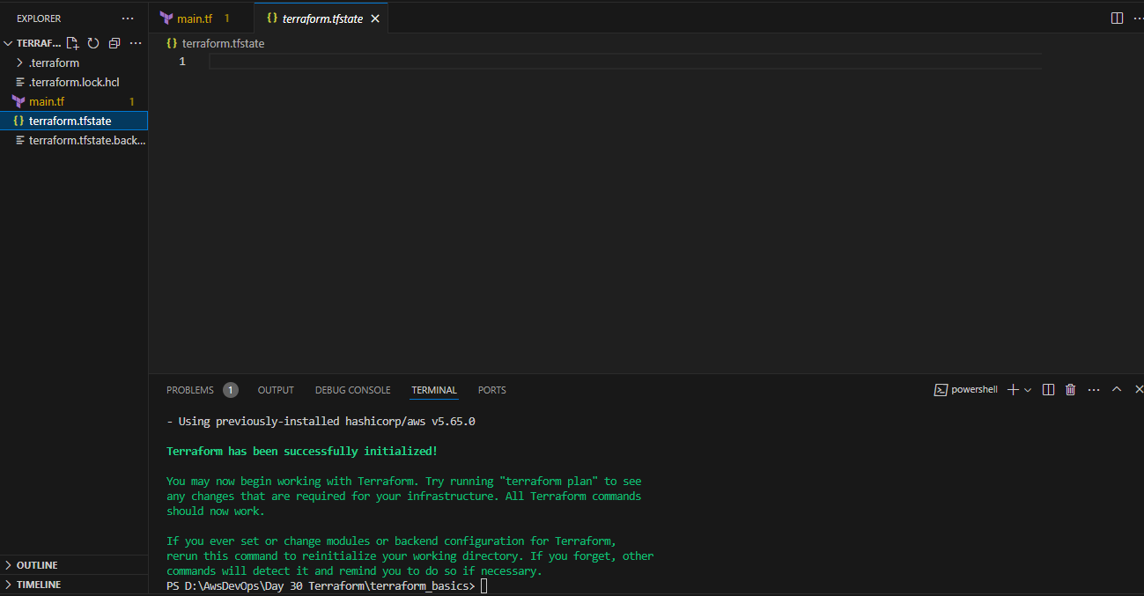

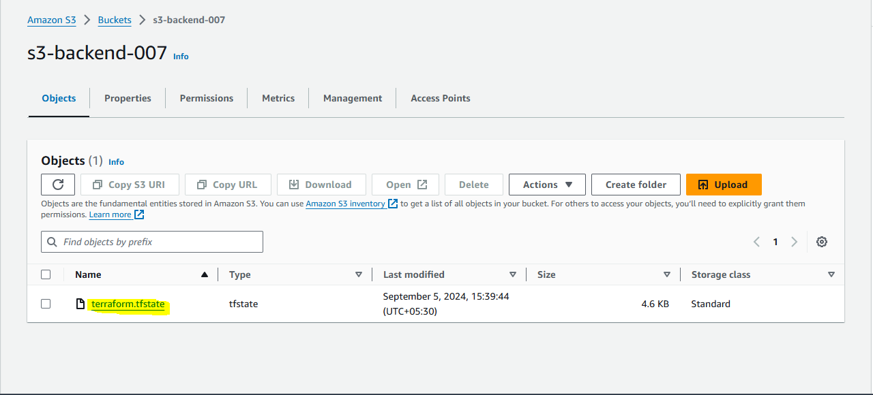

Let’s check whether it is lock or not by adding a resource to our script after adding I have tried to fire🡪 $terraform apply  
got error as it was lock by me so this means our lock is working fine  
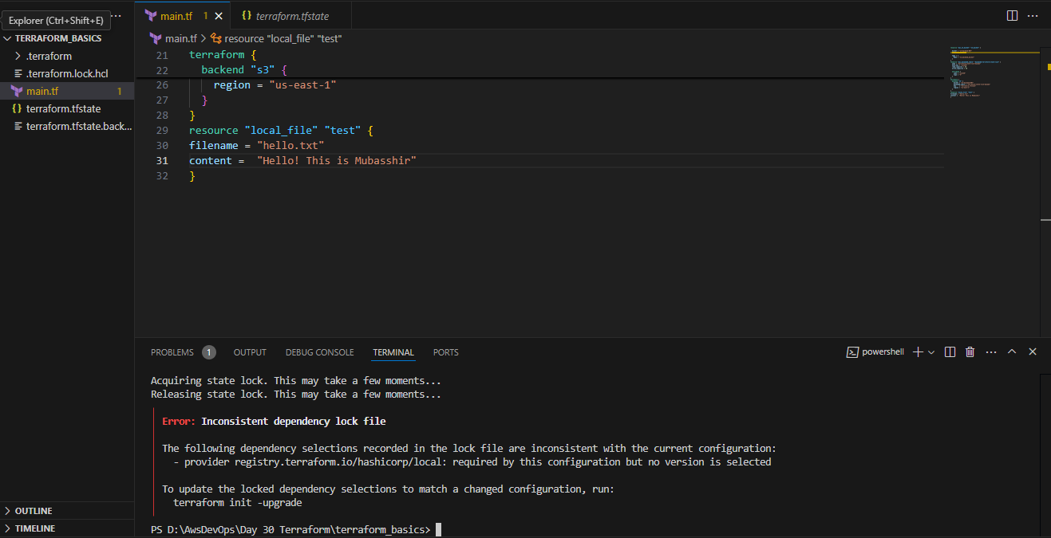

If we fire 🡪 $terraform init and then 🡪 $terraform apply then it will aquire the lock and we can work on it no other user can work. (As the file hello.txt is created)  
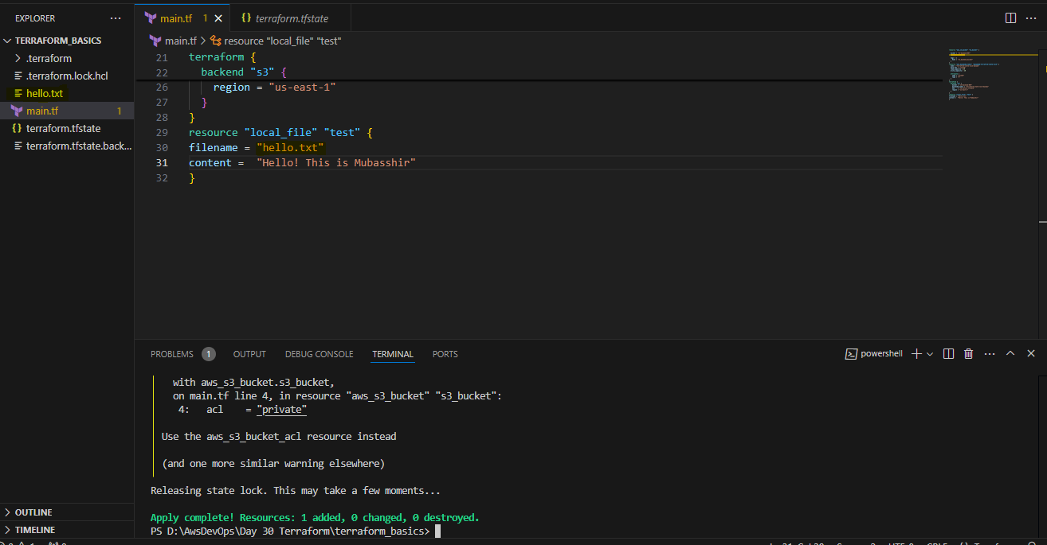

Let’s try to create an AWS EC2-instance:  
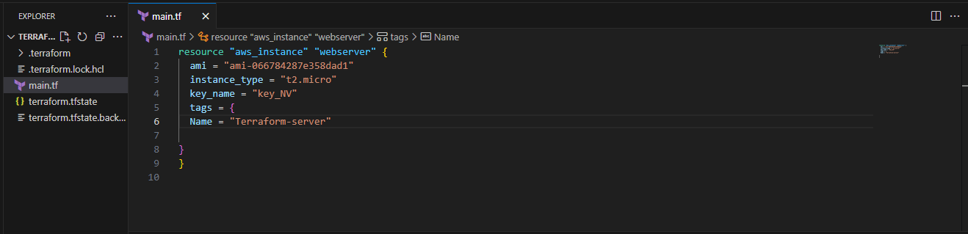

As I have manually deleted the S3 bucket it’s not able to work so creating new script in different place: 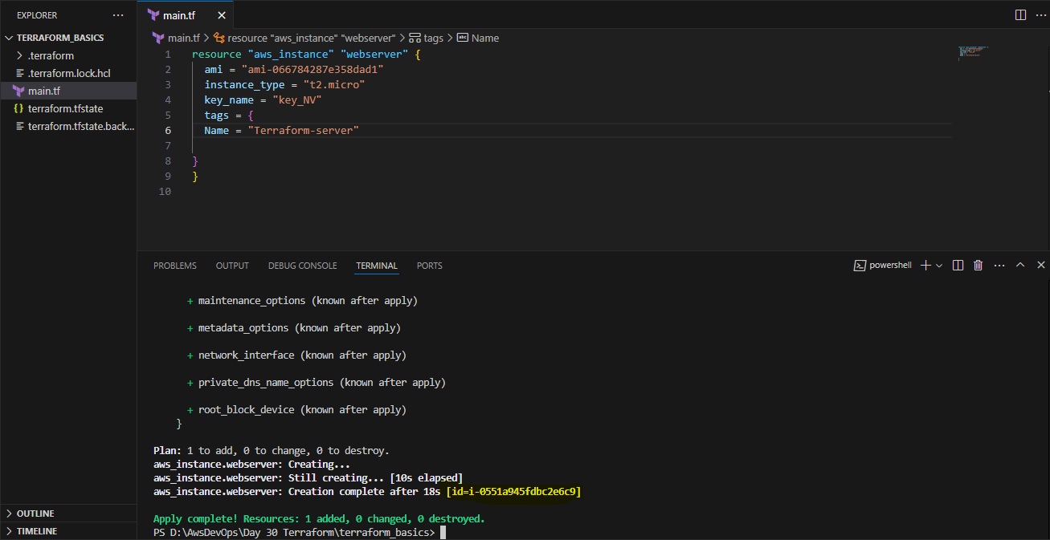  
Cross checked in the console: 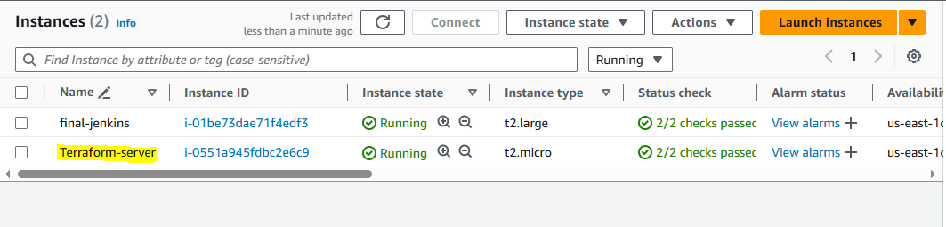

shutdown the instance by terraform destroy:  
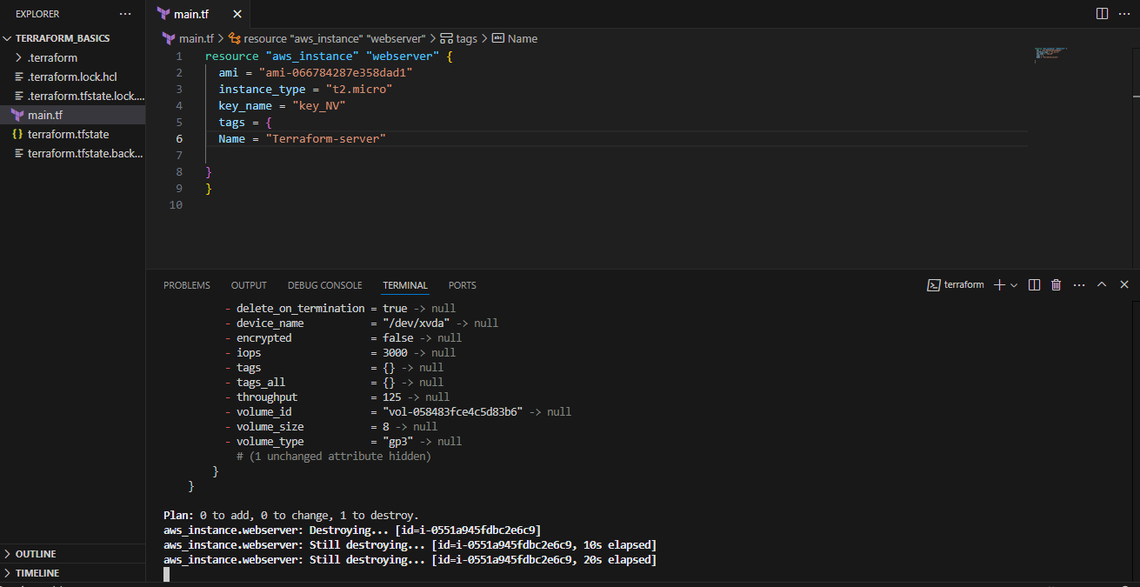  
  
Creating Ec2 with the help of remote Provisioner:   
Got error :  
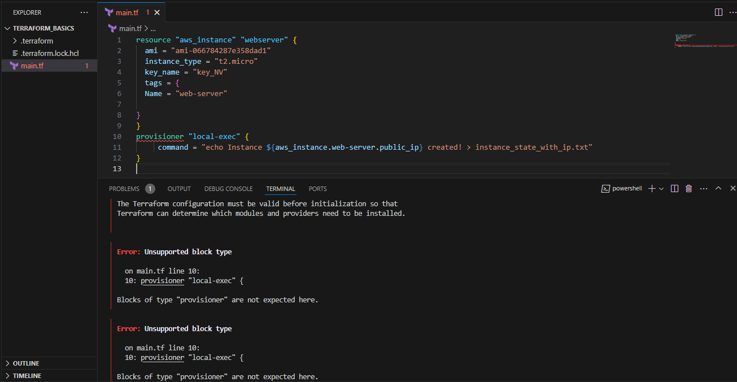  
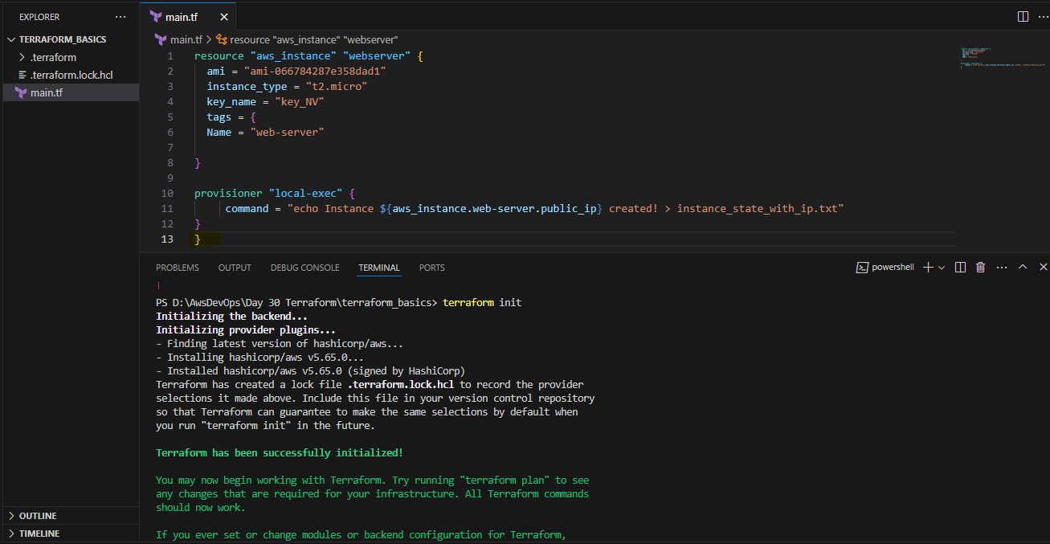  
the provisioner were getting outside of the code so added the bracket at the end then successeded.   
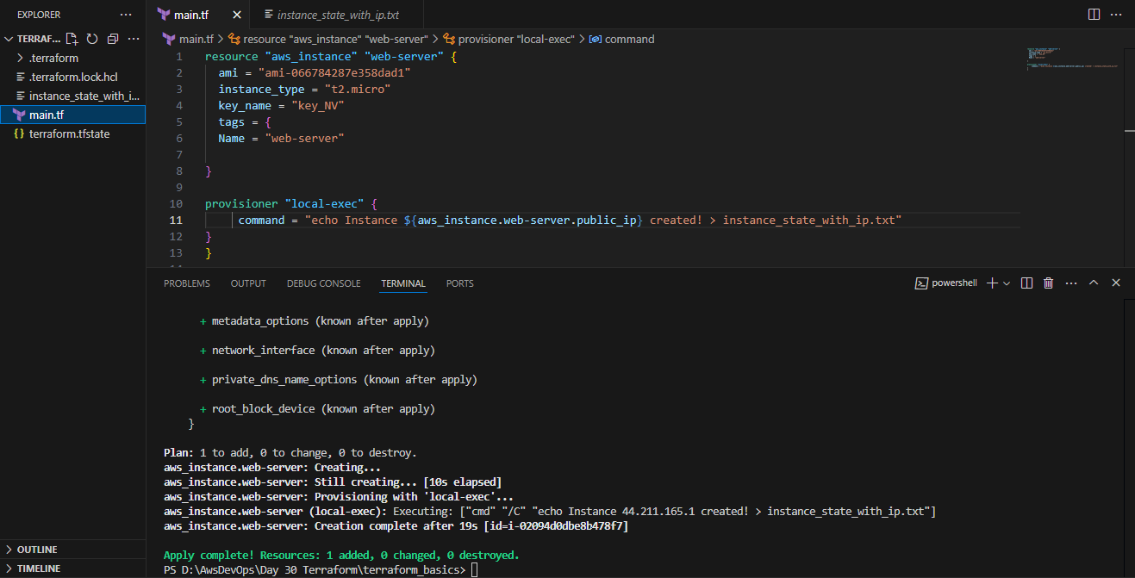

it has created the file with public ip as well:  
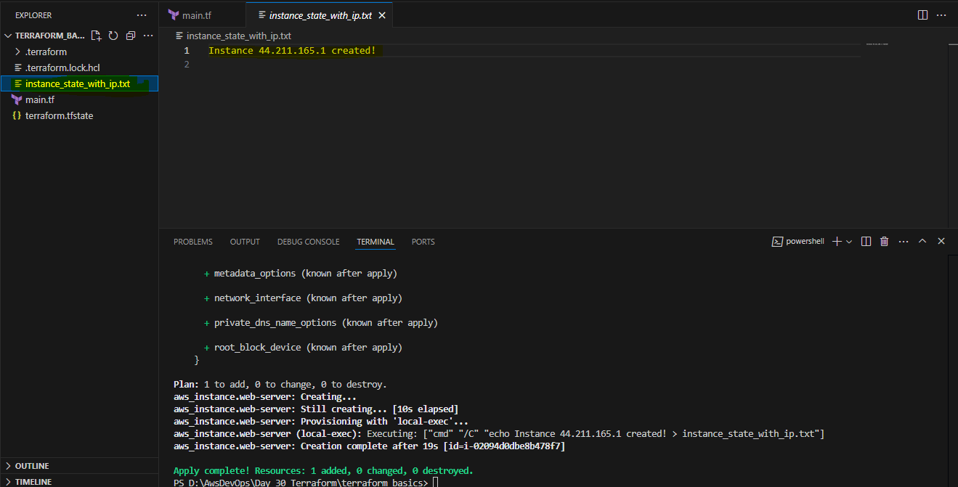 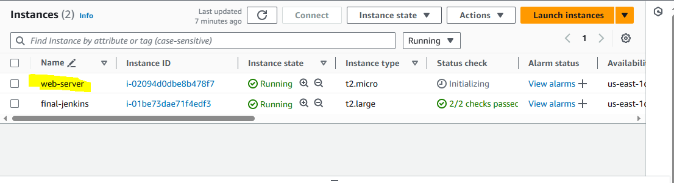

1. Create one ec2 instance with httpd installed using terraform script.  
   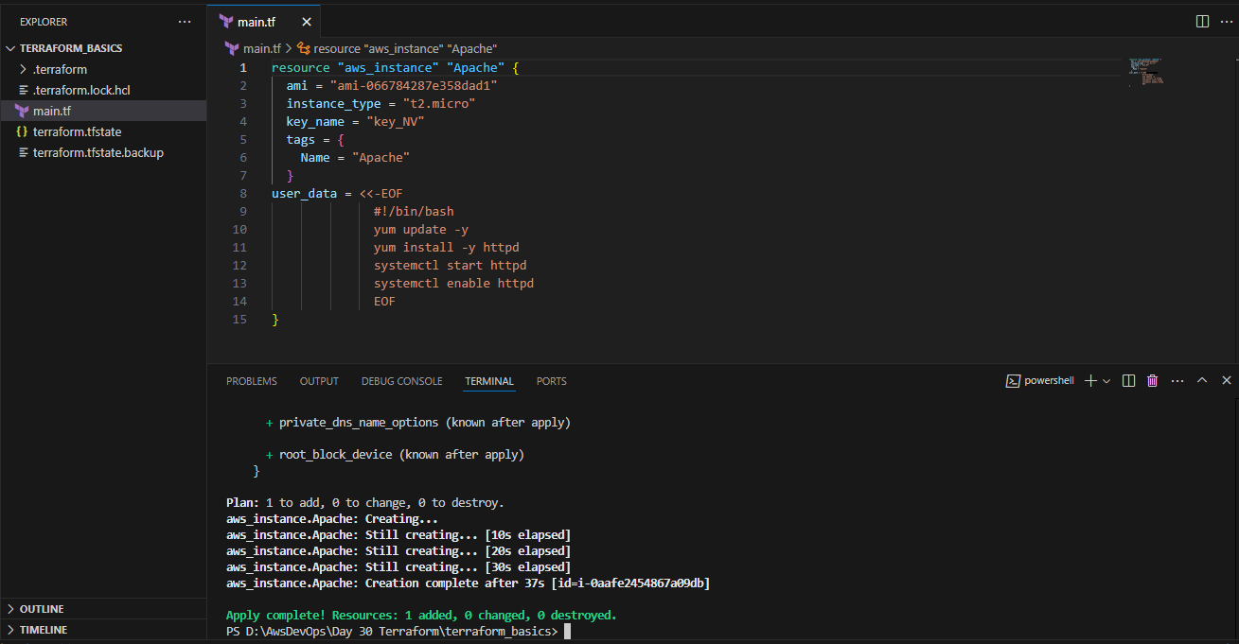  
     
    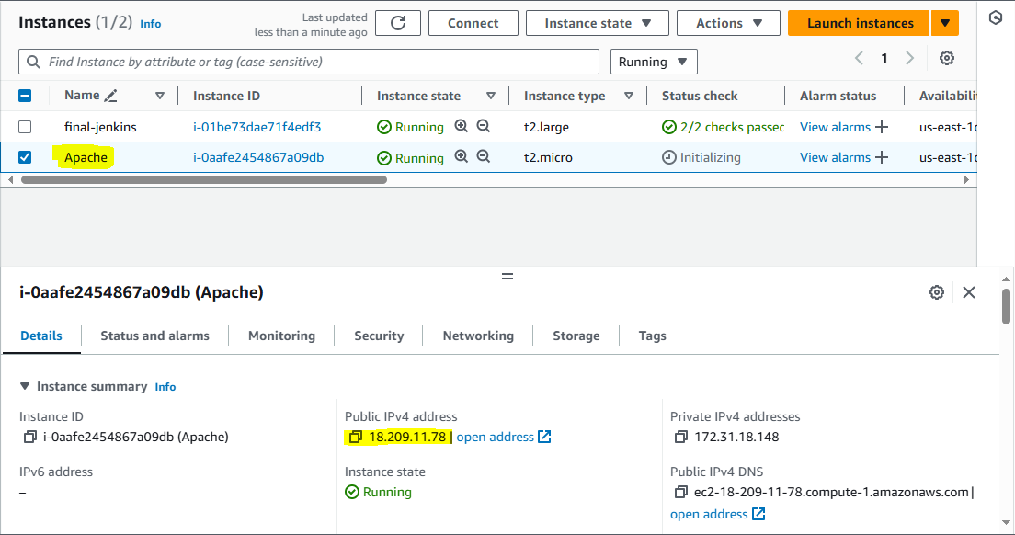

Tested the IP address:

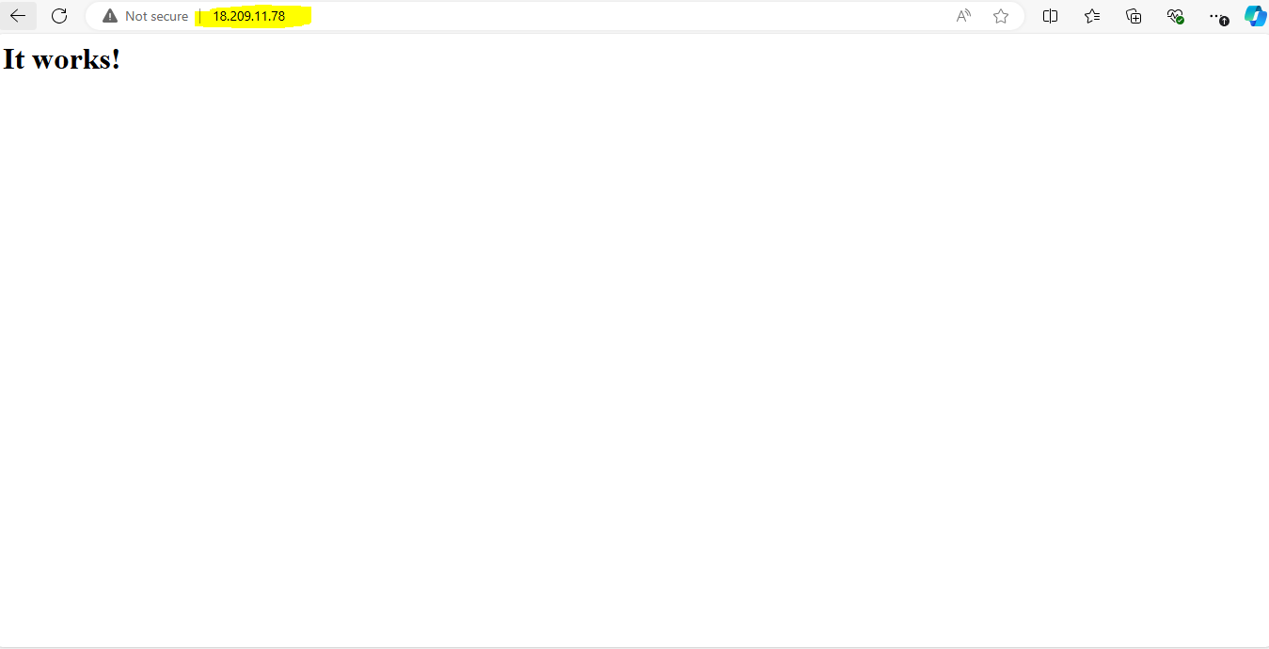

1. Setup s3 as backend to the task 3.  
   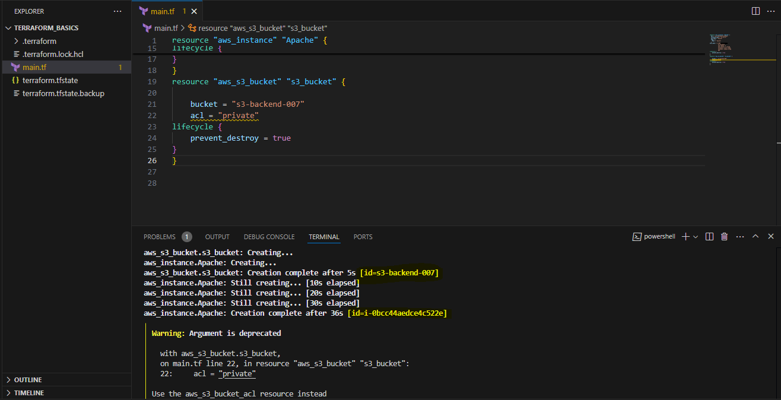
2. Setup dynamo db locking for task3.  
   